INCOMPLETE

[CS355] DATABASE SYSTEMS PROJECT PROPOSAL

***KHANA MANGWANA 🡨-*** NEED TO CHANGE SINCE THE DATABASE IS MORE THAN JUST ORDERING

***#include <Date>***

**Group Members:**

* Alina Qureshi (aq03798)
* Ali Mohammad Shujjat (as03856)
* Muhammad Shahrom Ali (ma03559)

**Abstract*:***

The idea is to create a unified food ordering and managing system for all three cafeterias/eateries at Habib University: This database system will manage all orders, allow placing orders online/on-the-go, and keep a record of all orders that have been placed in a day at each cafeteria/eatery.

**Implementation:**

1. *Entities:*
   1. *Students*
   2. *Professors*
   3. *Staff*
   4. *Menu*
   5. *Cafeteria*
   6. Tabs
   7. Inventory
   8. Customers
   9. Queue
   10. Orders for the day
   11. Days active
2. *Plan:*

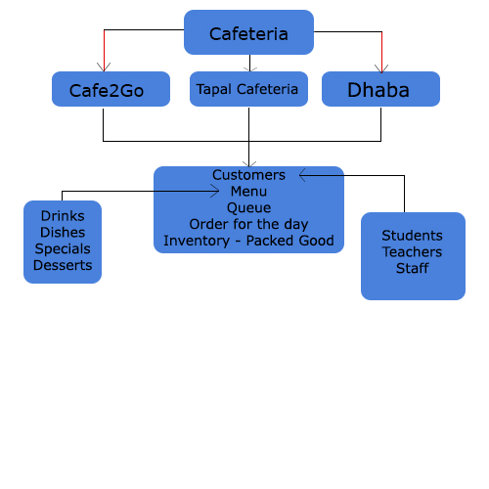

Each cafeteria will have customers. The customers will belong to one of three classes: Students, Faculty, or Staff. The cafeteria maintains their name, the amount they paid (or didn’t pay), and what they ordered; in case of a deficit in the amount paid, there is a separate entity of *tabs* that is maintaining the amount remaining for each customer. The database manages the food items for the day and also the stock of ingredients/packaged goods which will only be accessible to the cafeteria staff.